**Service Page Filter Implementation Process**

Firstly I added a base class (Service) to define common properties and a method that all services will share such as a title, price and dog size.

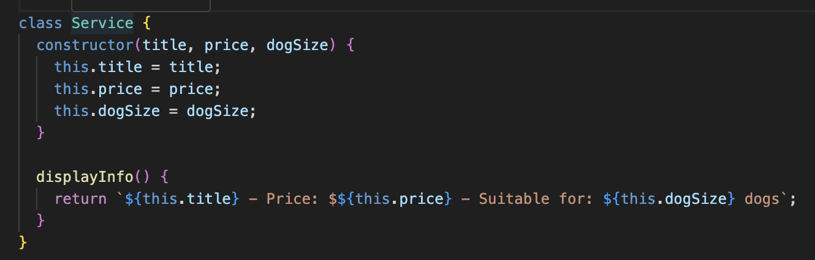

I then extended the service class to create more specific service types. The class’ inherit from service but adds a boolean value to indicate whether the service listed included a specific service such as blow-dry or teeth cleaning.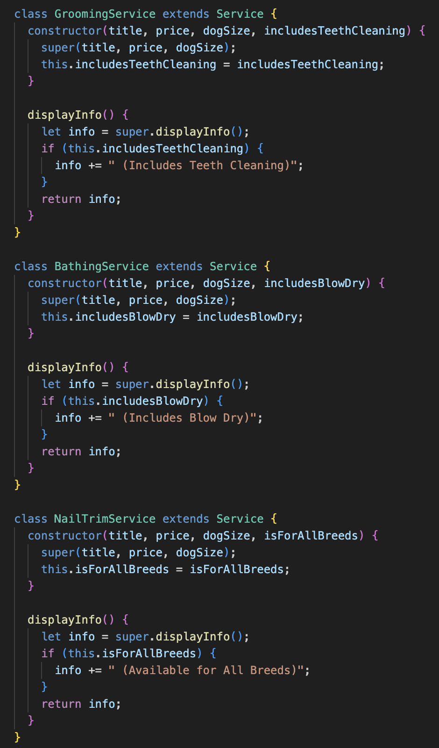

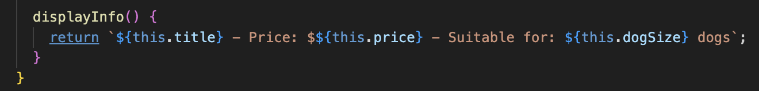

I then created an array of services, detailing what each service included and what dog size the service is suitable for. Each object is then instantiated using one of the three service subclasses (GroomingService, BathingService & NailTrimService.

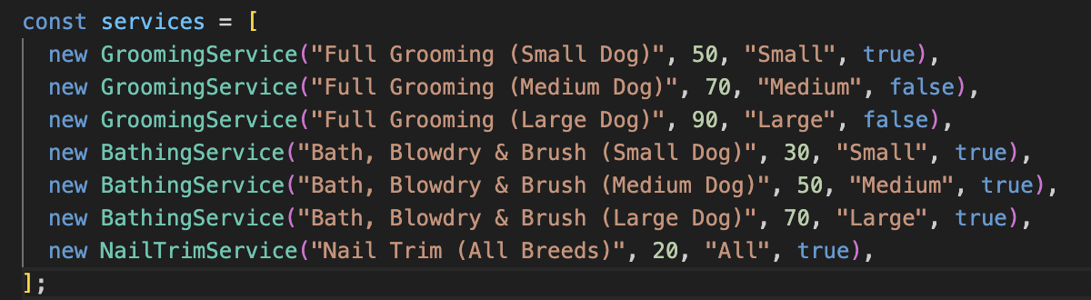

The below code was then added to ensure that all content is loaded when the page loads and an event listener was added to filter the services when the user selects a dog size from the dropdown.

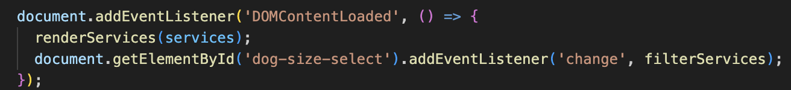

I then created a function that dynamically creates & inserts HTML elements for each service provided into the webpage.

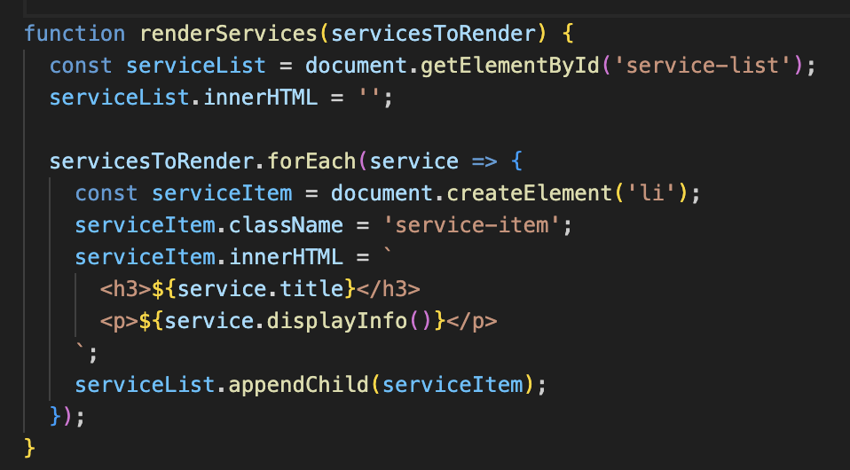

Finally, I added the function that allows the user to select a dog size from the dropdown menu and filters the services accordingly. It retrieves the selected dog size from the drop-down, filters the services array to only include matching services and then calls filteredServices to update the displayed services.

